Requirements Definition

*Movshare*

1. **Introduction and Context**

Oftentimes, someone will purchase a movie or book simply so they can read/watch it once, only to find out that a friend already has it. Alternatively, someone may own a popular movie and be constantly inundated with requests from friends to borrow it, making it difficult to keep track of who is in possession at any given time.

This project aims to build a web app that helps people manage and keep track of different kinds of media owned by themselves and others. In order to reduce duplicate purchases of movies and other media, this app will allow a group of users to store titles and details relating to their media collection. Each user will them be able to search for titles in each other’s libraries in order to share this media amongst themselves. This would also allow a user to purchase a gift for a friend without worrying about whether that friend already has the gift. The system will also allow for better record-keeping and accountability when loaning out titles.

1. **Users and their Goals**

This project has at most three users: a normal user, a media owner, and an admin. A media owner has access to all that a user has access to. An admin has access to everything both a user and a media owner has access to. Therefore, the projects users have the following hierarchy: An admin is a media owner, who is a normal user.

Normal User. A normal user needs to be able to request a media title from the database. They also need to see if the media is available for borrowing. They need to be able to select a title and view additional details for that item. They also need to manipulate the display of the database with the following functionality, namely sort and filter by various categories (i.e. title, media type, owner, etc…).

Media owner. A media owner needs to be able to do all a normal user can do in addition to adding and removing media they own from the database. They also need to be able to approve loan requests made by normal users for media they own.

Admin. An admin is there to be able to edit all aspects of the database regardless of who owns the media. This account would be separate from the other accounts and would need to have a normal user account to use the program as intended.

1. Use Case Diagram.

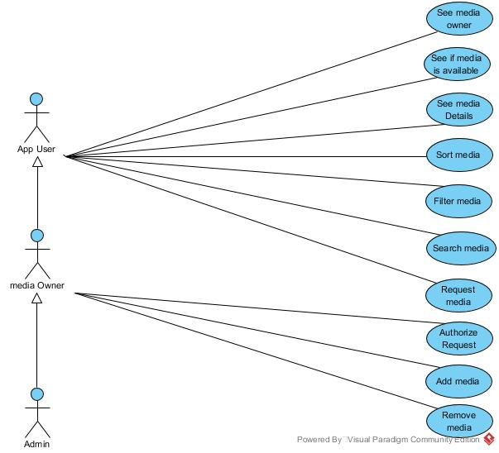

1. **Functional Requirements**
2. User Authentication
   1. The system must require all users to authenticate themselves before giving them access to view or take actions on Movshare.
      1. They must be able to create an account with a username and password the first time they access Movshare
      2. They must be able to log in on subsequent visits to Movshare using the same username and password. If they log in successfully, they should gain access to Movshare. If they did it incorrectly, they should be prompted to try again.
3. User Libraries
   1. The system should allow users to add media entries to their User Library.
      1. When an entry is created, users will be required to list a title and media format. They should also have the option of list additional information under an ‘additional notes’ category.
4. Search and Request Function
   1. The system should allow users to browse other user’s libraries.
      1. Users should be able to browse libraries by user.
      2. Users should be able to search all libraries by title and media format.
      3. Searches should show all information stored in the media entry in a search.
   2. The system should allow users to ‘request’ a title from another user.
      1. The media owner should receive an alert informing them of which media item has been requested, and who requested it.
         * 1. The media owner should be able to accept or deny the request.

If the request is accepted, the system should mark the media item as unavailable for anyone who may see it in search results.

* + - * 1. The system should send an alert to the requester informing them whether the owner refused or denied their request.
        2. When a request is approved, the media item will appear in the requester’s shelves.

The requester can return the media item by finding it in their shelves.

1. **Non-functional Requirements**

* Development will follow a Scum-based Agile process, a Scrum board and Sprints lasting roughly a month. Scrum meetings will occur on Mondays, Wednesdays, and Fridays after class. There will also be weekly iteration meetings.
* Team members will use Slack to communicate in-between scrum meetings.
* Git will be used for version control. Pushing directly to the master branch is strictly forbidden.
* The project will be built using Django in a Docker container.
* CircleCI will be used to assist with integration testing.

1. **Future Features**
2. Integration with a mobile app that includes support for scanning barcodes. Scanning the barcode of a piece of media might allow a user to search for that media in other user libraries, or to add the media to their own library.
3. A wishlist function.
4. **Glossary**

User – A generic person who uses Movshare.

Media/media item – A movie, book, magazine etc. that is owned by a user

Media Collection – The physical collection of all pieces of media owned by a user

User Library – A database that users may add media titles to, which may then be searched by other users.